

**Project-3**

**Graphs**

**Of**

**Grafana**

**Node overview dashboard**

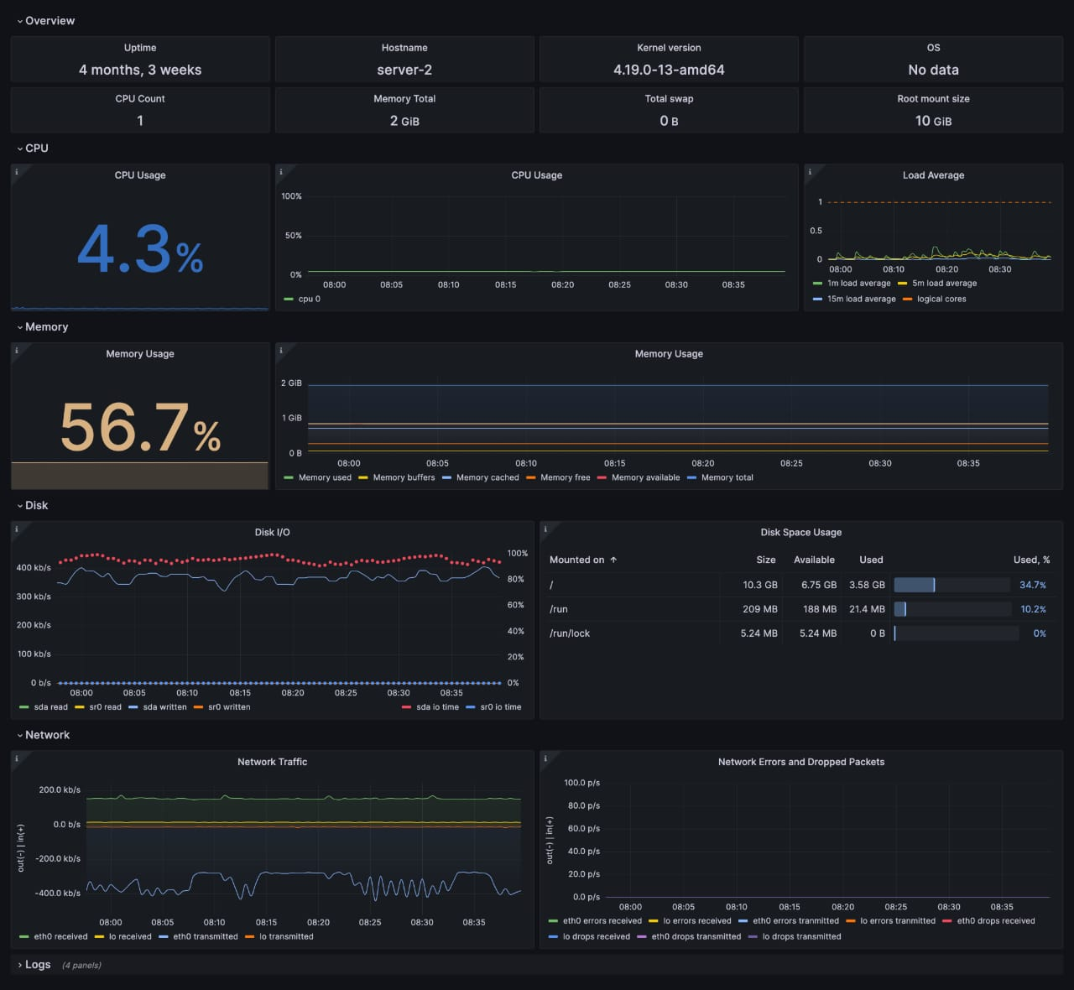

**Fleet overview dashboard**

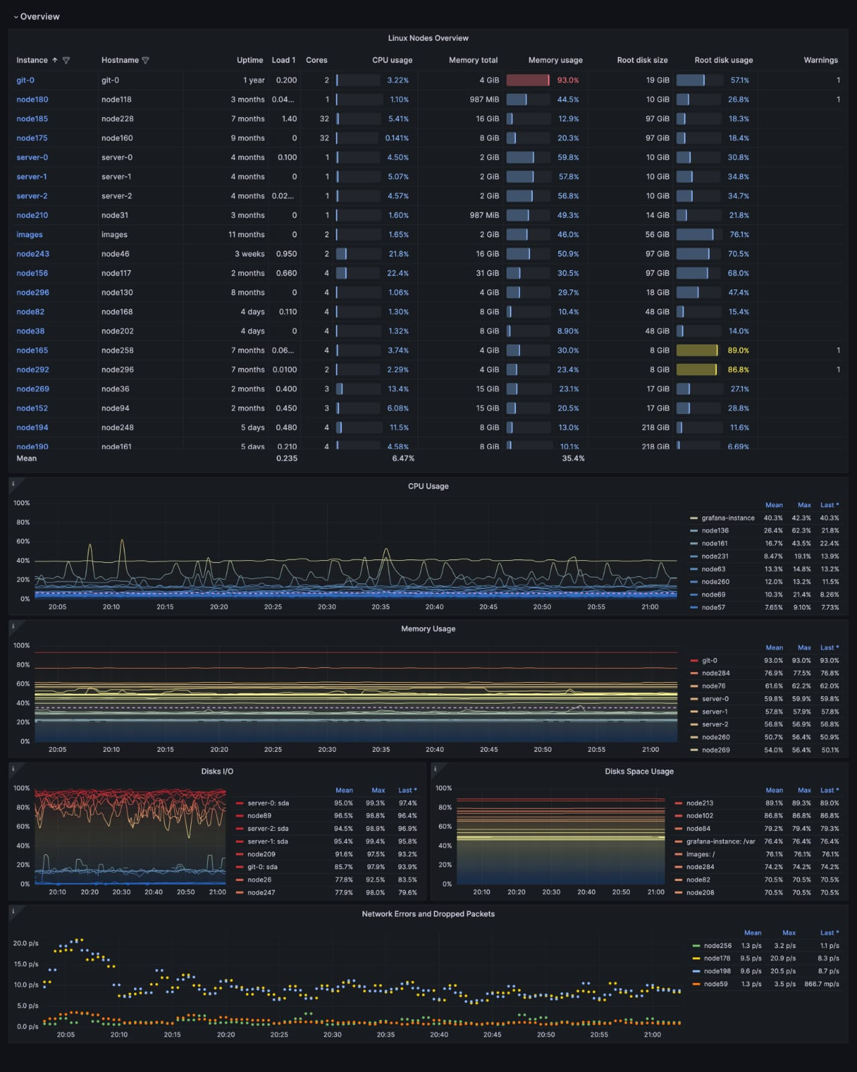

**Drill down dashboards :Network interfaces**